Project: Todo Application Test Plan
Course: CSD 380 – DevOps and Software Testing
Description: This document explains the functional test plan for the Todo web app. It includes five test cases that check whether users can add, see, update, and delete tasks, and whether a custom 404 page appears for invalid URLs. Each test makes sure the app works the way it’s supposed to.
Date: 2025/11/13
To complete the test case plan, fill out the information for Project, Course, Description and Date in the header below.

.
TABLE OF CONTENTS
Introduction ………………………………………………………………………………………………………………………………………………………………………………………………………. 1
Test Objectives ………………………………………………………………………………………………………………………………………………………………………………………………….. 2
Test Cases ………………………………………………………………………………………………………………………………………………………………………………………………………….. 3
Test 1 – View Todo List ………………………………………………………………………………………………………………………………………………………………………………………. 3
Test 2 – Create a Todo Item ………………………………………………………………………………………………………………………………………………………………………………. 4
Test 3 – Edit an Existing Todo Item ……………………………………………………………………………………………………………………………………………………………………. 4
Test 4 – Delete a Todo Item ………………………………………………………………………………………………………………………………………………………………………………. 5
Test 5 – Handle Invalid URLs ……………………………………………………………………………………………………………………………………………………………………………… 6

For each test, the developer should: provide a test description, a test objective, the developer name and date tested. For each step, fill out the actions to be taken and describe the expected results, and indicate yes or no for each step depending upon the result. The peer tester should provide their name, date tested, indicate yes or no for each step depending upon the result, and a screenshot (thumbnail) of the result.

Test 1 | Access the Todo Application
 | Test Objective: Verify that users can access the Todo application through the provided URL. | Developer: Jose Flores  Date tested: 2025/11/13 | Peer tester: Colby King  Date tested: 2025/11/17
Step | Action | Expected results: | Developer pass/fail | Tester pass/fail  + Screenshot
1 | Open a web browser. | Browser opens. | PASS | yes
2 |  | The Todo homepage loads. | PASS | yes
  Go to https://buwebdev.github.io/todo/.
3 | Verify that “Welcome to the Todo App!” is displayed. | Welcome message appears clearly at the top. | PASS | Yes 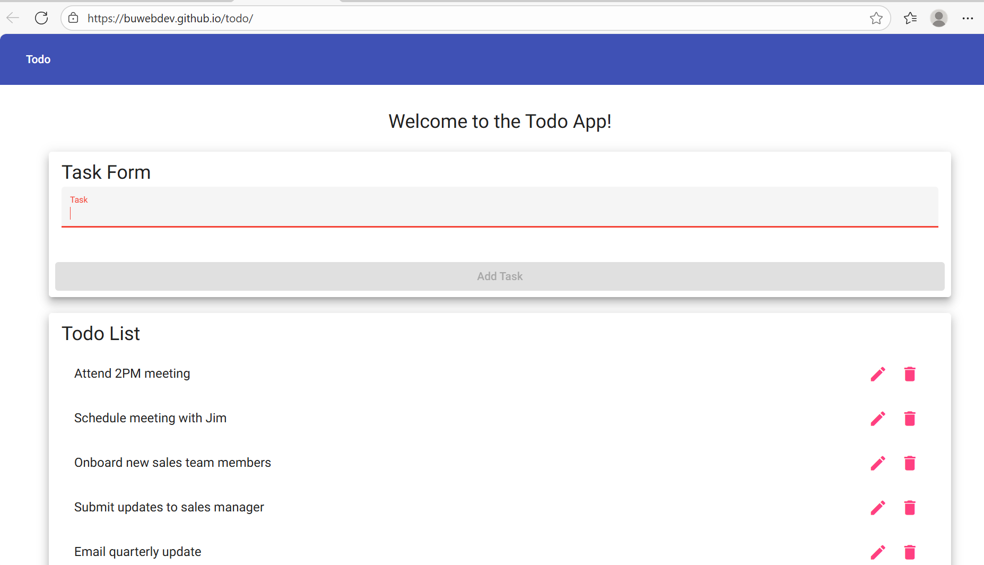
4 |  | Both sections are visible with sample tasks. | PASS | Yes
  Check “Task Form” and “Todo List” sections appear.
5 | Refresh the page. | Page reloads with no errors. | PASS | yes
Comments | The site loaded quickly and showed the right content. Everything looked correct when refreshed, and the app is ready to use.

Test 2 | Create a New Todo Item
 | Test Objective: Verify that a user can successfully add a new task to the list. | Developer: Jose Flores  Date tested: 2025/11/13 | Peer tester: Colby King  Date tested: 2025/11/17
Step | Action | Expected results: | Developer pass/fail | Tester pass/fail
1 | Open the Todo app in a browser. | App loads. | PASS | yes
2 |  | Cursor appears, ready for typing. | PASS | yes
  Click in the Task input box.
3 |  | Text displays correctly in the field. | PASS | yes
  Type “CSD 380 Assignment.”
4 | Click the Add Task button. | The new task appears at the bottom of the Todo List. | PASS | yes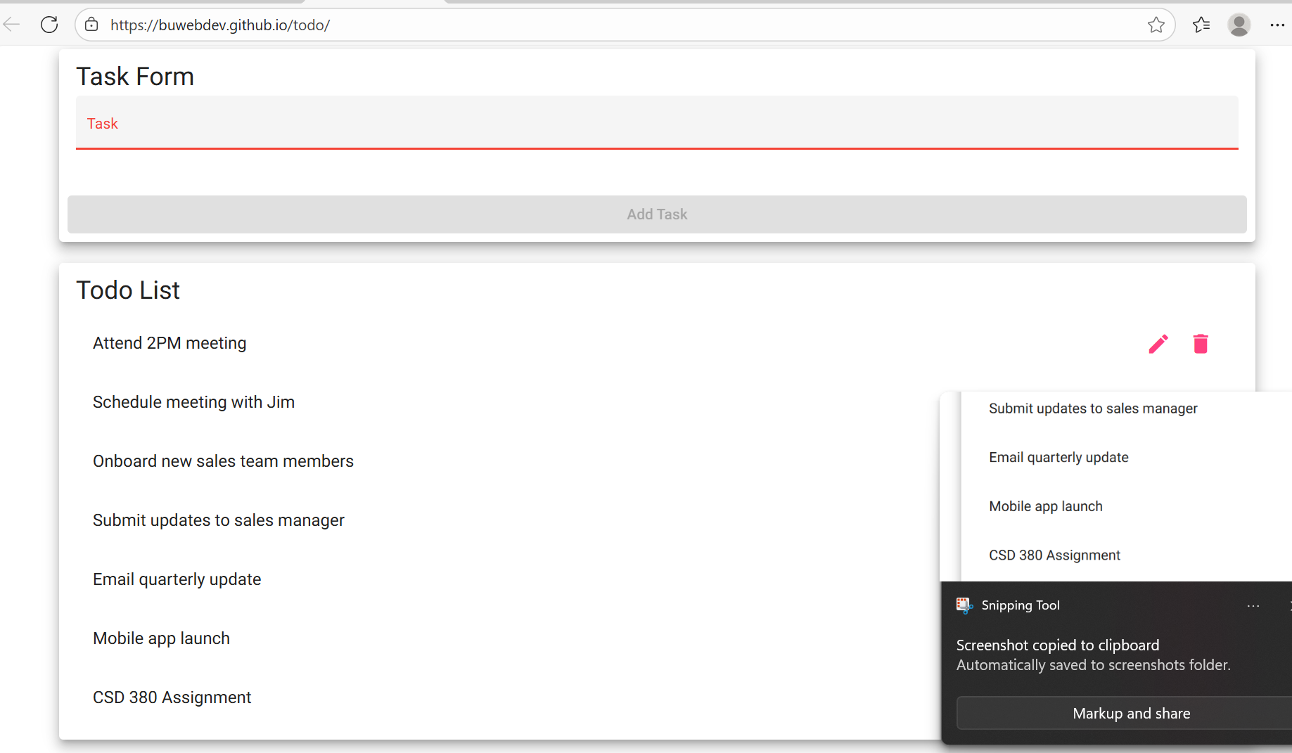
5 | Check the new item. | Task remains visible after action completes. | PASS | yes
Comments | The new item was added without issues. The list updated instantly and displayed the entered text correctly. This confirms the add function meets requirements.

Test 3 | Edit an Existing Todo Item
 | Test Objective: Verify that a user can modify an existing task. | Developer: Jose Flores  Date tested: 2025/11/13 | Peer tester: Colby King  Date tested: 2025/11/17
Step | Action | Expected results: | Developer pass/fail | Tester pass/fail
1 | Make sure a task is in the list | Task is visible | PASS | yes
2 | Click the Edit button next to the task. | Task becomes editable. | PASS | yes
3 | Change the task text to “CSD 380 Assignments to CSD 380 Projects.” | Text updates in the input area. | PASS | yes
4 | Save the edit. | Task text updates in the list. | PASS | Yes  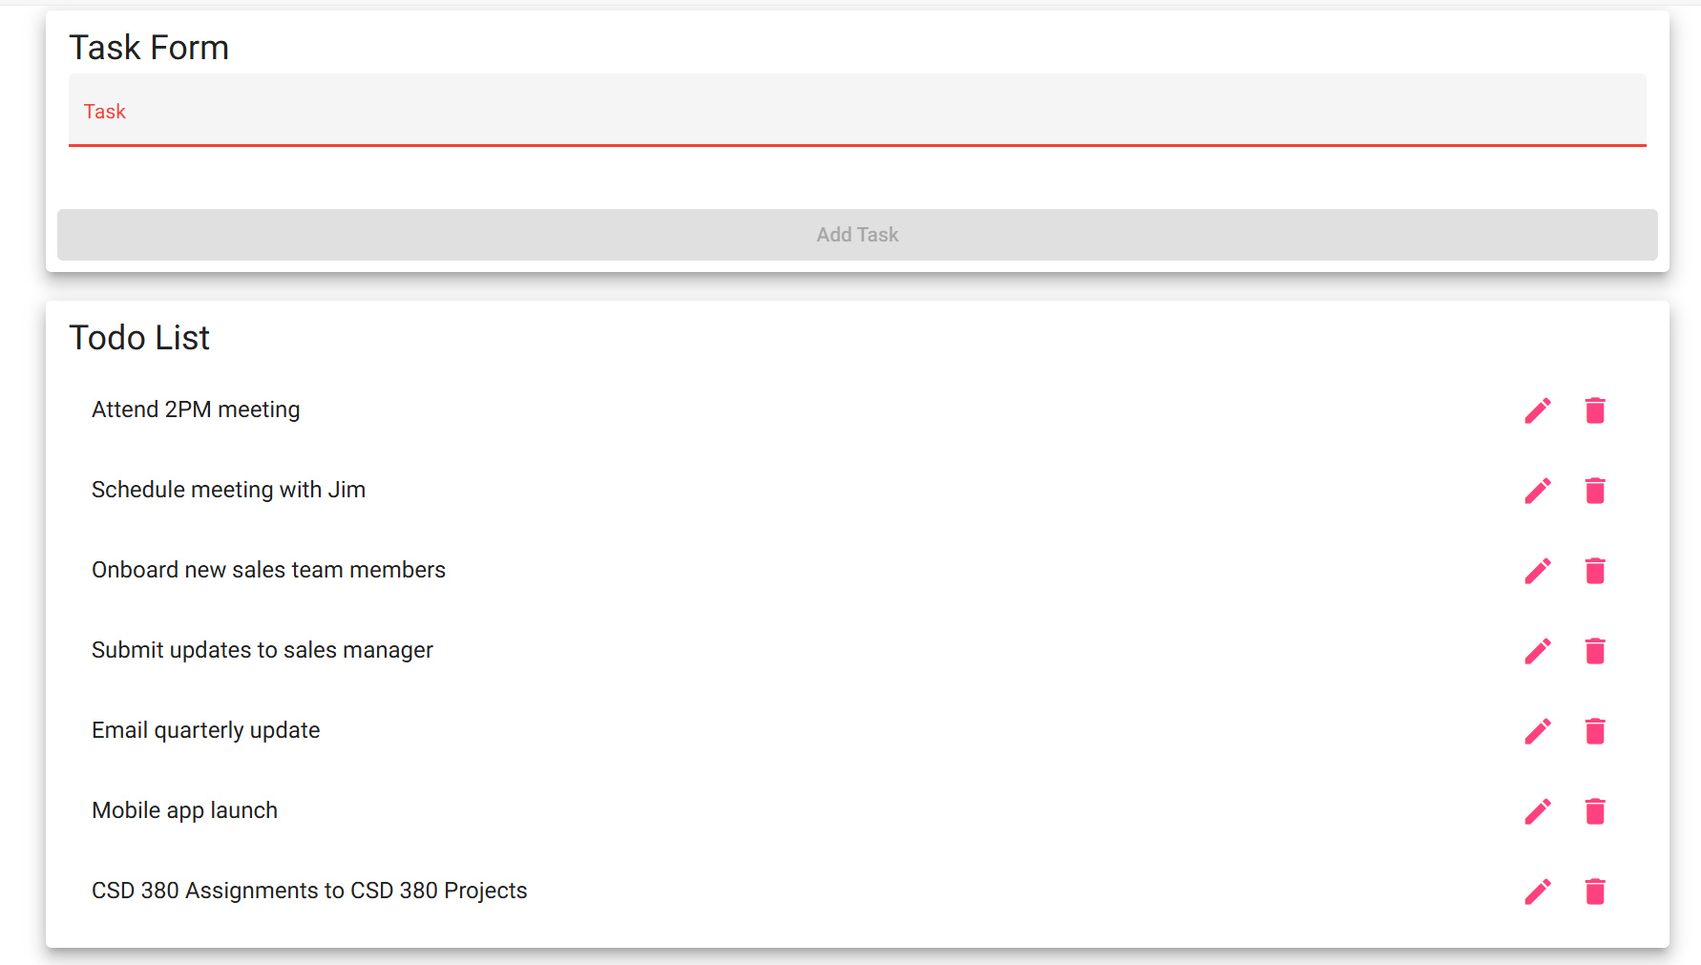
5 | Refresh the page. | The edited task goes back to the original text because changes aren’t saved. | FAIL | yes
Comments | Editing a task works while you are on the page, the text updates immediately, and it’s clear which task is being edited. But after refreshing, the change disappears because the app doesn’t save data. Users might expect their edits to stay.

Test 4 | Delete a Todo Item
 | Test Objective: Confirm that users can delete a task from the list. | Developer: Jose Flores  Date tested: 2025/11/13 | Peer tester: Colby King  Date tested: 2025/11/17
Step | Action | Expected results: | Developer pass/fail | Tester pass/fail
1 | Find a task in the list (ex.., “Mobile app launch”). | Task is visible. | PASS | Yes
2 |  | The selected task disappears from the list. | PASS | yes
  Click the Trash icon.
3 | Refresh the page. | The deleted task comes back because the app doesn’t save changes. | FAIL | Yes 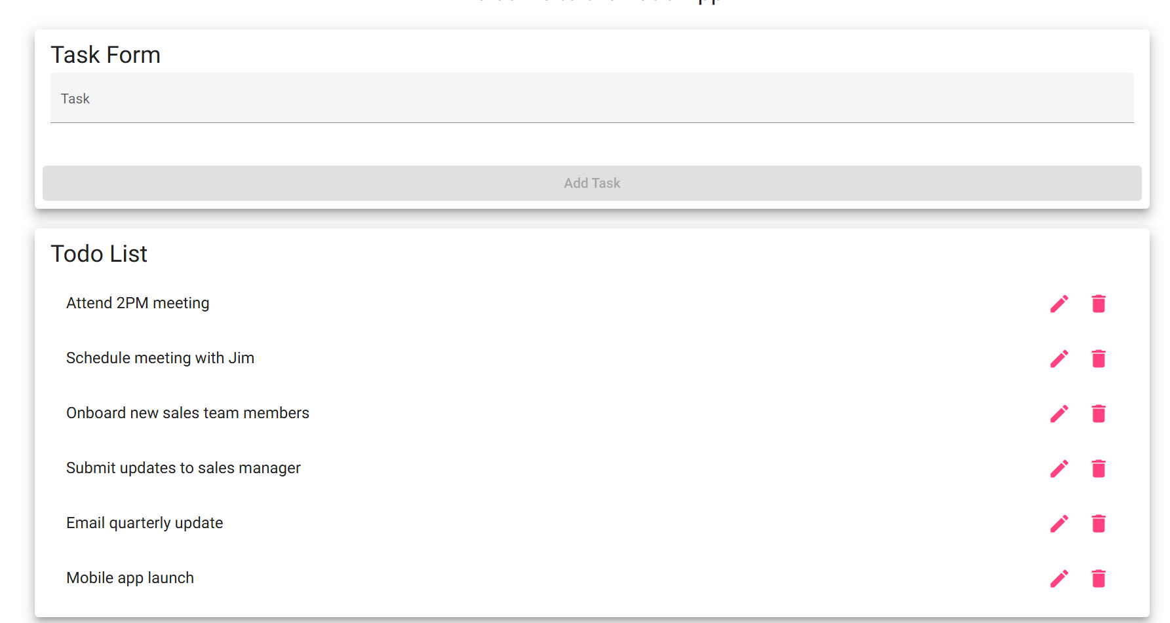
4 | Try deleting another task. | Function repeats successfully. | PASS | yes
5 | Confirm list updates immediately. | Remaining items stay visible. | PASS | yes
Comments | Deleting a task works while you are on the page, the task disappears immediately when clicking the Trash icon. However, after refreshing, the deleted task comes back because this version of the app does not save changes. This is expected for a static Todo app, but users may expect deletions to stay permanent.

Test 5 | Handle Invalid URLs
 | Test Objective: Ensure the app displays a custom 404 error page when visiting an invalid URL. | Developer: Jose Flores  Date tested: 2025/11/13 | Peer tester: Colby King  Date tested: 2025/11/17
Step | Action | Expected results: | Developer pass/fail | Tester pass/fail
1 | Open a browser. | Browser launches successfully. | PASS | yes
2 |  | Page loads a “not-found works! message. | PASS | yes
  Navigate to https://buwebdev.gith ub.io/todo/fakepage.
3 |  | Displays app’s own 404 page with message: “not-found works!” | PASS | Yes 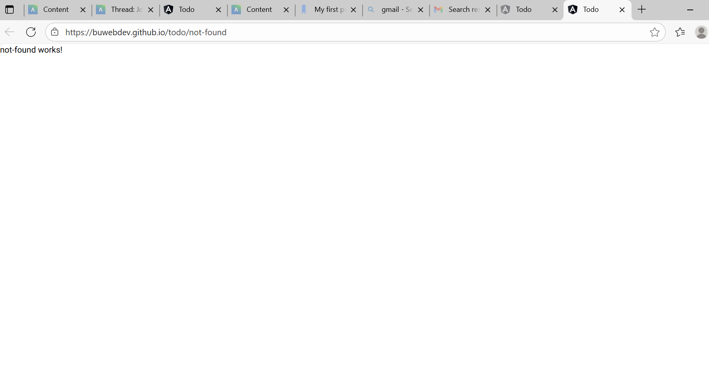
  Check if the message.
4 | Return to main URL. | App homepage loads normally. | PASS | yes
5 |  | Home displays without error. | PASS | yes
  Refresh the main page.
Comments | The app correctly shows a custom 404 page with the message “not-found works!” instead of the browser’s default error. This helps users know the page doesn’t exist and keeps the design consistent with the main site. Returning to the homepage works normally, and refreshing does not cause any problems.

